|  |  |  |
| --- | --- | --- |
| 8 | **BOSTON**  **UNIVERSITY** | **METROPOLITAN COLLEGE**  **DEPARTMENT OF ADMINISTRATIVE SCIENCES** |

**AD 616: Enterprise Risk Analytics**

**Assignment 2**

**Aravind Hanumantha rao**

1. Answer the following two questions.
   1. According to the *central limit theorem*, the sum of *n independent identically distributed* random variables will start to resemble a normal distribution as *n* grows large. The mean of the resulting distribution will be *n* times the mean of the summands, and the variance *n* times the variance of the summands. Demonstrate this property using Monte Carlo simulation. Over 10,000 trials, take the sum of 100 uniform random variables (with min=0 and max=1). Note: the variance of the uniform distribution with min 0 and max 1 is 1/12. Include:
      1. A histogram of the results of the MC simulation

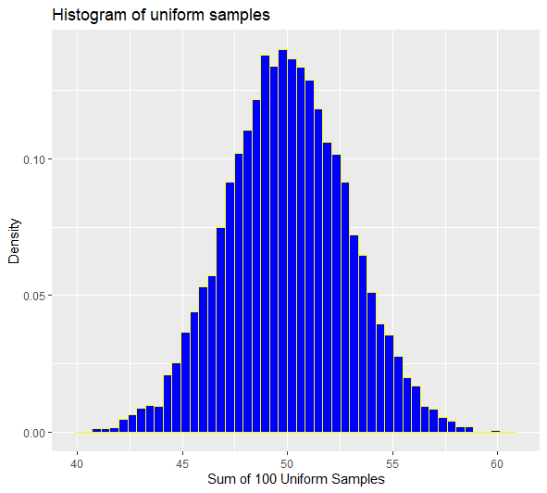

The histogram shows the sum of 100 uniform samples when run for 10,000 trials . As the histogram is formed for the data .

So the sum of 100 samples is formed from the runif function and entered into the matrix . Summing the rows of 10,000 trails with 100 columns gives the sum of the samples

* + 1. A density plot of a normal distribution with the appropriate mean and standard deviation

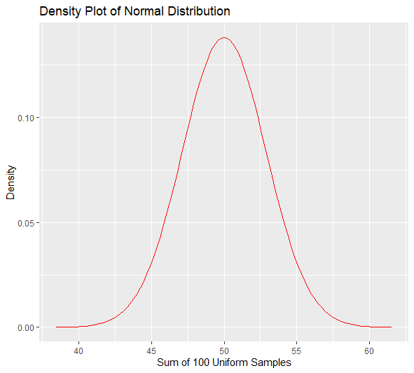

As we can see from the histogram and relate with the density plot , the mean is calculated from the average of min and max of the uniform distribution . If the min is 0 and max is 1 then the average of the uniform distribution is 0.5 because it’s a uniform distribution . When multiplied with the 100 uniform variables , it gives a mean of 50. Knowing the variance of the uniform distribution is 1/12 , the 100 uniform variables will have a variance of 8.33.

So the mean being 50 and variance of 8.3 and using 4 standard deviations which covers a area of 99.75 percent from the mean, the density plot is constructed.

* + 1. The mean and standard deviation of the MC simulation.

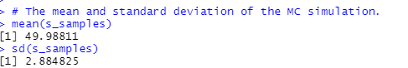

* 1. According to probability theory, if $\left\{X_{1},…X_{n}\right\}$ are independent and *uniform distributed* random variables with min=0 and max=1, then the *kth* lowest will follow a *beta distribution* with parameters *shape1=k*, *shape2=n+1-k.* Demonstrate this property using Monte Carlo simulation. Simulate 10,000 trials. For each trial, generate 10 uniform random variables and select the 3rd lowest. Include:
     1. A histogram of the results of the MC simulation

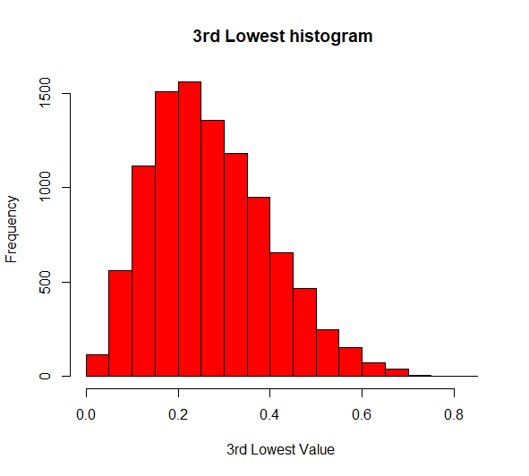

When applying the sort function for samples with the given attributes and running the runif function with the trials and the n value we get this histogram .

Sort function with margin one, sorts by the rows in ascending order and assigning k = 3 will take the 3rd lowest from the sorted values from the 3rd column. They consist of 10 columns and 10,000 rows.

* + 1. A density plot of the beta distribution with the appropriate parameters

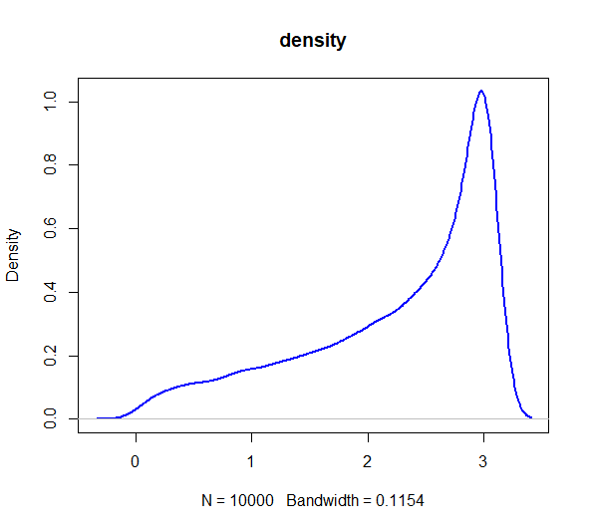

Given the 2 parameters and the k_lowest values we can construct the beta density. calculated the values of k_lowest from the sorting function . These values get inserted into the S1 and S2 parameters to give a beta distribution

* + 1. The mean and standard deviation of the MC simulation

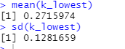

1. Assume you represent a worldwide distributor of classic cars. Create a Monte Carlo simulation with 10,000 trials to demonstrate the property that, if the amount of time it takes before your next customer makes a purchase can be modelled using an exponential distribution with a rate of 10 per day, then the number of times customers will make purchases in a day will follow a Poisson distribution with $λ=10$. Develop a histogram to reinforce your result.-

Given the rate of 10 and trials of 10000, we can calculate the random exponential values . These values can be appended into the matrix. The reason I took 100 columns is because to get a dispersed values for the time taken for the next customers. The columns are for each time and the rows are the purchases for each trial.

So , the apply function sums the exponentials to get the know the value of one purchase and that is transposed into a row and column matrix . the reason of transpose is because it only cumsums by the rows and not to the columns and transpose it can fix the issue. Transpose converts the rows of the matrix in column and column of the matrix in rows.

Then for the FOR loop will check until the values reach 1 and count it as one purchase for the day and it does it for the other 10,000 trials. It sums the results to produce a final result of the purchase for the rows and the columns.

This can be produced into a histogram:-

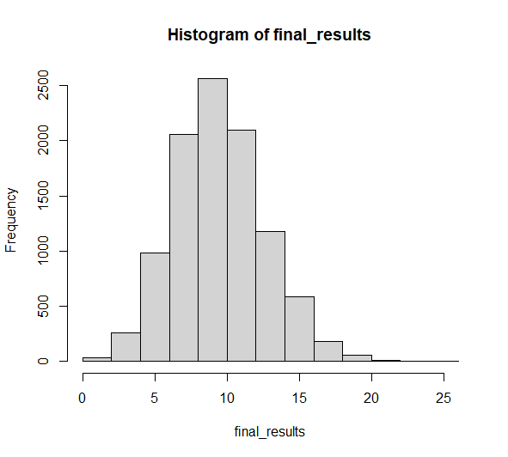

1. A life insurance company is pricing a new policy to sell to a group of 45-year-old male non-smokers. They determine that the probability that a member of this group will die *X* years from the day they purchase the policy can be modeled with a Weibull distribution with shape parameter 4.5 and scale parameter 39, measured in years. The term of the policy is 20 years. At the end of every month, policy holders are expected to pay $115. If a policy holder in good standing dies during the term of the policy, his beneficiaries receive a lump sum of $1,000,000 at the end of the month. Every month there is a 0.3% chance that the policy holder will let the policy lapse (i.e. he will permanently stop paying premiums and forfeit his right to the benefit). The insurance company calculates cost of funds using a rate of 6.5%

Create a Monte Carlo simulation with 10,000 trials of the above scenario to calculate the net present value of cash flows to the insurance company for one policyholder.

1. Create a histogram describing the NPV. How would you characterize the distribution?

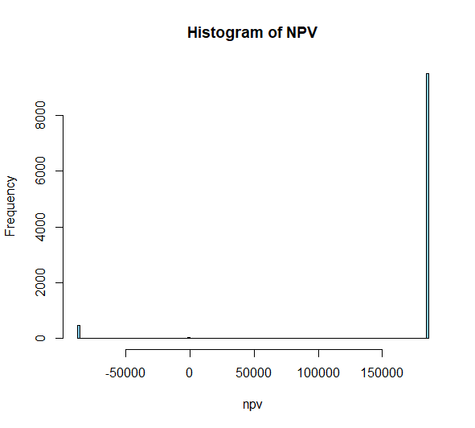

It shows 3 conditions – one is 185093 , zero and -86923

1. What are the mean and standard deviation of the NPV? On balance, is the insurance company making a profit?

Mean is 171470.63 and standard deviation is 58895.46

1. Provide a 95% confidence interval for the mean of the NPV. Interpret the result.

95% confidence interval for the mean of the NPV (170316.167266759, 172625.106389196).

1. How many iterations would be necessary to provide a **99%** confidence interval with a half width of $200?

The number of iterations needed for a 99% confidence interval with a half width of $200 is 575358

1. The company can be 90% sure their npv will be at least *x.* Solve for *x.*

*The company can be 90% sure their NPV will be at least $185092.51.*The company can be 99% sure their npv will be at least *y.* Solve for *y.*

The company can be 99% sure their NPV will be at least $-86923.63.

Now assume the insurance company underwrites 1,000 policyholders. Create a Monte Carlo simulation with 1,000 trials to calculate the net present value of cashflows for the insurance company made to all the policy holders. *(Hint: Recycle your work above. Create a list of data frames, where each element of the list represents one trial.)* Answer questions (a)-(e) above under this assumption.